Cavendish Close Infant and Nursery School 2022.23

Our Core Purpose
Our children are all unique. They have big hearts and great energy.
All our children are stars and we find and nurture their strengths.
Our children have fun loving personalities and they like to talk about their experiences. They thrive with our routines and expectations.
Our children deserve the best and we are committed to enabling them to be the best that they can be.
Some of our children present us with barriers to their development and learning. We are committed to working in partnership with our parents and carers as well as the local community and appropriate agencies to meet the needs of our children.
All our children deserve quality time and interaction with the key adults in their lives.
We are committed to developing high aspirations within our school community. We provide all our children with rich and varied experiences.
It is important that our children leave us with an understanding of the world that they are growing up in, having learned how to live alongside, and show respect for, a diverse range of people.
We provide our children with opportunities to learn about the protected characteristics in meaningful ways through our curriculum. We advance equality, promote diversity, challenge discrimination, show respect to everyone and choose kindness.
To enable our children to succeed in life, we have STAR Expectations and we work towards our 8 Behaviour Values and 10 Learning Values.
Together, we can all shine.

Our Vision
We want our children to achieve our STAR Expectations and succeed in life within an ever-changing world.
We want our children to be ready for the next stage of their education personally and academically.
When our children move on from us, we want them to be:

Our STAR Expectations
At Cavendish Close Infant and Nursery School, we are all stars.
Together, every day, we reach for the stars.

Together, we can all shine.

Our 10 Learning Values

 |  |  | 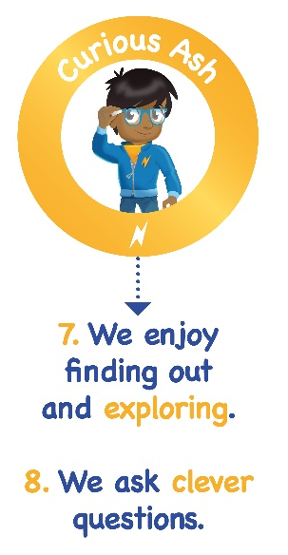 | 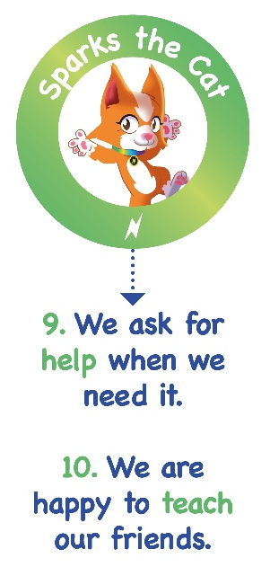

Our 8 Behaviour Values

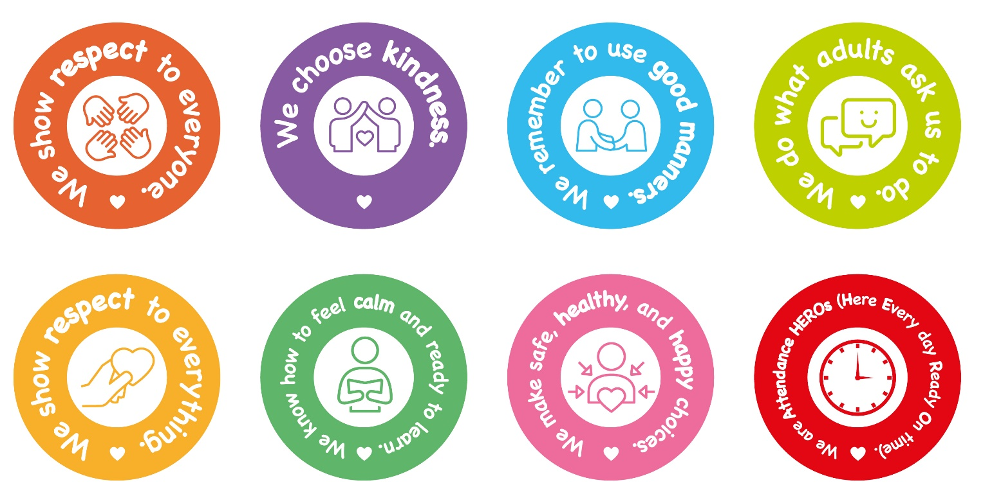

Our Ethos

At our school…

We create indoor and outdoor environments that are…

- Welcoming
- Positive and happy
- Safe and calm
- Orderly
- Inviting, stimulating, and engaging

We are committed to developing high quality continuous provision with accessible, relevant, and open-ended resources that promote enquiry-based learning.

We expect the adults in our school to…

- Have high expectations
- Be effective communicators
- Build strong relationships
- Connect to children’s lives and interests
- Make every child feel valued
- Model self-awareness and self-regulation
- Be calm and patient
- Be positive and consistent
- Be nurturing and encouraging
- Be empathetic and responsive

- Model our STAR Expectations, our Behaviour Values, and our Learning Values.

- Focus on the children in our care during morning and afternoon learning time.

“I am the decisive element in the classroom. It is my personal approach that creates the climate. It is my daily mood that makes the weather. As a teacher, I possess tremendous power to make a child’s life miserable or joyous. I can be a tool of torture or an instrument of inspiration. I can humiliate or humour, hurt or heal. It is my response that decides whether a crisis will be escalated or de-escalated, a child humanised or dehumanised.”
Haim Ginott (An Israeli Child Psychologist and Psychotherapist)

We motivate our children to learn by…

- Planning learning topics that are relevant and exciting with meaningful reasons to read, write and be numerate across the curriculum.
- Bringing subjects to life, enjoy being Historians, Artists etc.
- Connecting learning to our children’s lives and interests.
- Finding the story in learning (People, Places, Problems and Possibilities).
- Ensuring that learning has:
- a HOOK (a wow starter)
- a PURPOSE (a challenge)
- and an AUDIENCE
- Valuing the process of learning as well as the outcome.
- Giving our children the time and space to learn in greater depth.
- Enabling our children to make choices in their learning.
- Helping our children to work independently and collaboratively using their communication and social skills.
- Creating enabling environments with relevant and interesting resources

Our School Pedagogy can be found in our Teaching and Learning Handbook.

We learn…
10% of what we read
20% of what we hear
30% of what we see
50% of what we see and hear
70% of what we discuss
80% of what we experience
95% of what we teach others
William Glasser (An American Psychiatrist)

We expect our Parents and Carers to…

- Respect the ethos, vision, and values of our school.
- Work together with staff in the best interests of our children.
- Treat all members of our school community with respect, kindness, and good manners.
- Set a good example to our children with language and behaviour.
- Seek a peaceful solution to all issues.
- Correct their own child’s behaviour (or those in their care) where it could lead to conflict, aggression or unsafe conduct.
- Approach the right member of staff to help resolve any concern.

We expect our Governors to…

- Meet their statutory duties and get to know the school well
- Act in the best interests of all the children
- Actively support and challenge the school
- Make decisions impartially and fairly
- Act with honesty and integrity
- Be accountable for decisions made and action taken
- Work collaboratively for the benefit of the school

