**Education City 25.5.20**

It is an interactive learning platform to support studying at home. Cavendish Close Infants School have invested in a subscription for all our children as we feel that it is an excellent tool to support home learning.

Work is carefully selected by your teachers to reflect the curriculum in your child’s current academic year.

It’s a place to access many subjects in one place, especially maths, English, and phonics.

Teachers update it on a weekly basis so there is plenty for your children to explore.

It’s also a great tool for teachers to monitor your child’s progress progress

**What is**

**Education**

**City?**

**Games**

**+**

**Activities**

**+**

**Learning screens**

**+**

**‘Think it’ conversation starters**

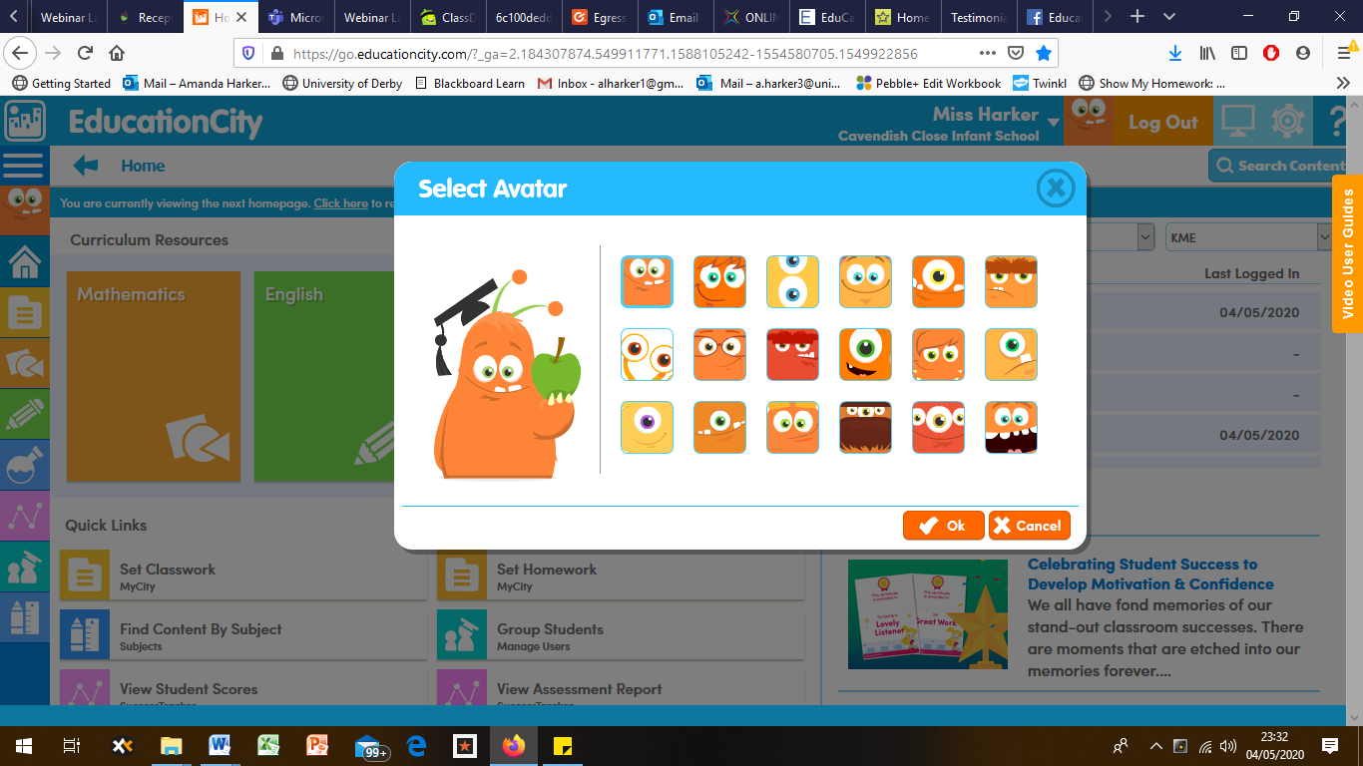

“Both my children in different year groups enjoy it, and keep going back to it again and again. Very easy to use! And I am happy they are doing work like school”

**Please head to:** [**www.educationcity.com**](http://www.educationcity.com) **and use your login details to sign-in.**

Any problems getting on we are happy to help, so get in touch.

It’s simple to navigate the website, and most of the resources are tablet-friendly too.

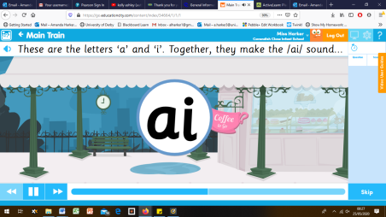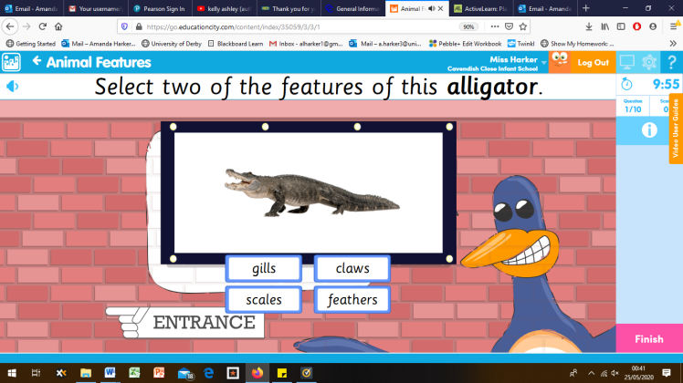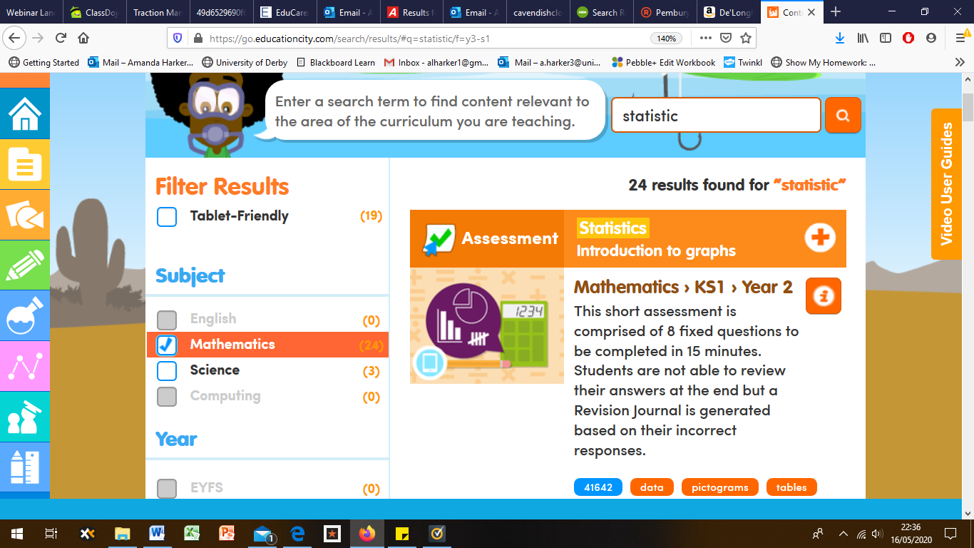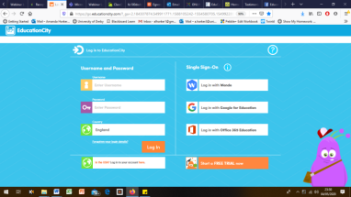

**Year 1:**

Animals including humans

Position and direction

**How do I**

**log on?**

**Reception:**

One more, one less

The phoneme ‘ai’

**Year 2:**

Statistics

Spelling rules recap

0

What’s **NEW** this week for your child on Education City?

“He didn’t even know he was learning, as he was playing a game”